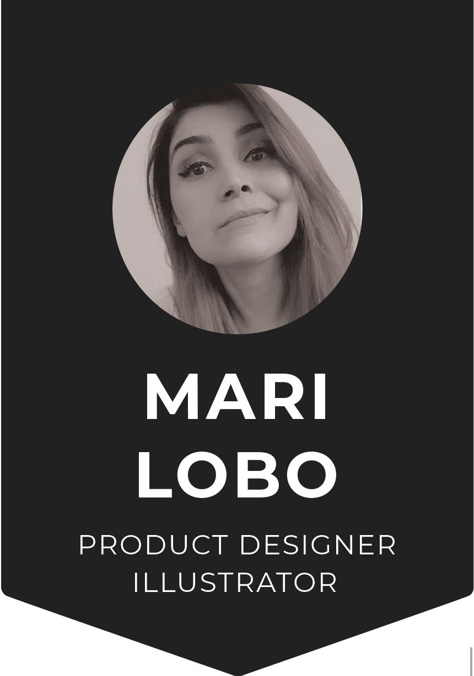
•
PROFILE
Name Nationality
Language
Marilia Nobre Lobo
Brazilian-Green Card Holder
Portuguese Native English Fluent
•
CONTACT
Address 3704, Roosevelt ave, Richmond,
California, United States 94805
Phone
(1) 510-258-2768
Email
Website
marilobo.artl@gmail.com

www.marisketch.com
•
SKILLS
Drawing Painting Photoshop
Procreate
11lustrator Zbrush
Keyshot Free Form
Smart Sheet Airtable Basecamp
Google apps
-----======
- =====
-_ -_ -_ -_ -_ -_ -_ -_ -_ -_
-----=======

e WORK EXPERIENCE

0 Product Designer/Toy Designer

Super7 (2079-2023)
Action Figures, Concept Design, Colorguides, Sculpt Direction, Production. Disney, Nickelodeon, Warner Brothers, GI Joe

O Children's Book Illustrator

Shannon Associates (2020-2027)
Represented Freelancer Illustrator, Published with Scholastic

Children's Book Illustrator

0 Astound Agency (2077- Current)
Freelancer Illustrator, Published by National Geographic Kids, Sterling Publishing, Cottage Door Press, Capstone, Scholastic

Background Designer

0 Class Dojo (2077-2077)
Contract Work .Responsible for drawing and painting background envirorments for their new animated series.

O Textile Designer

Several clothing companies in Sao Paulo, Brasil (2006-2070)
Created Graphics for clothing companies mostly children Clothes

EDUCATION

0 MFA in Visual Development for Animation
Academy of Art University, San Francisco (2073-2077)

0 BA Industrial Design
Faculdades Oswaldo Cruz SP, Brazil (2003-2007)

0 Advanced Character Design
Animation Collaborative -Pixar School (2077-2077)

O Advanced Character Design

Animation Collaborative -Pixar School (2077-2077)

- Social Media
fi

MARI.Sl(ETCH
@) MARI.Sl(ETCH
D MARI_Sl(ETCH

